**Advance Excel Assignment 6**

1. What are the various elements of the Excel interface? Describe how they're used.

Ans. **Microsoft Excel XP** is a spreadsheet application in the **Microsoft Office suite**. A spreadsheet is an accounting program for the computer. The primary purpose of a spreadsheet is to work with **numbers** and **text.** Spreadsheets can be used to **organize data** like alphabetizing a list of named or sorting records, as well as to calculate and analyze data using mathematical formulas,

The following are the basic parts of the Microsoft Excel Window:

* Quick Access Toolbar : This toolbar is located in the upper left corner of the screen. Its objective is to show the most frequently used Excel commands. We can customize this toolbar based on our preferred commands.
* File Tab : Excel 2007's Office button has been replaced by the File tab. We can click it to **check the Backstage view**, where we can **open** or **save files, create new sheets, print sheets**, and perform other **file-related operations**.
* Title Bar : The title bar of the spreadsheet is at the top of the window. It displays the **active document's name.**
* Control Buttons : Control buttons are the symbols that are present in the **upper-right side** of the window, enabling us to change the **labels, minimize, maximize, share,** and **close the sheet.**
* Menu Bar : Under the **diskette** or **save icon** or the **excel icon** (this will depend on the version of the program**), labels** or **bars** which enable changing the sheet which is shown. These are the menu bar and contain a **File, Insert, Page Layout, Formulas, Data, Review, View, Help,** and a **Search Bar** with a **light bulb** icon. These menus are divided into subcategories which simplify the distribution of information and analysis of calculations.
* Ribbon/Toolbar : Each menu bar contains several different elements. On the selection of the menu, a sequence of command options/icons will show on a ribbon. For example, if we select the "Home" tab, we will see cut, copy, paste, bold, italic, underline, and more commands. In the same way; we can click on the "Insert" tab, we will see tables, illustrations, additional, recommended graphics, graphics maps, among others. On the other hand, if we select the "Formulas" option. Insert functions, auto sum recently used, finances, logic, text, time, date, etc.

Ribbon/Toolbar is a set of commands organized into three sections.

* Tabs: They are the Ribbon's top part, and they include groups of related commands. Ribbon tabs include Home, Insert, Page Layout, Formula, Data.
* Groups: They organize related commands; the name of each group is displayed below the Ribbon. For example, a set of commands related to fonts or a group of commands related to alignment, etc.
* Commands: They appear within each group, as previously stated.
* Dialog Box Launcher : Dialog box launcher is a very little down arrow that is present in the **lower-right** corner of a command group on the Ribbon. By clicking on this arrow, we can explore more options related to the concerned group.
* Name Box : Show the location of the active cell, row, or column. We have the option of selecting multiple options.
* Formula Bar : Formula bar permits us to observe, insert or edit the information/formula entered in the active cell.
* Scroll Bars : Scrollbars are the tools that enable us to **move the document's vertical** and **horizontal** views. We can activate this by clicking on the platform's internal bar or the arrows we have on the sides. Additionally, we can use the **mouse wheel** in order to automatically scroll up or down: or use the directional keys.
* Spreadsheet Area : It is the place where we enter our data. It includes all the **rows, cells, columns**, and **built-in data** in the spreadsheet. We can use shortcuts to perform toolbar activities or formulas of **arithmetic operations (add, subtract, multiply, etc.)**. The insertion point is the blinking vertical bar known as the **"cursor."** It specifies the insertion location of the typing.
* Leaf Bar : Leaf bar is present at the bottom of the spreadsheet, which says **sheet1** is shown. This sheet bar describes the spreadsheet which is currently being worked on. Using this, we can alternate a number of sheets or add a new one as per our convenience.
* Column Bar : Columns are a vertically ordered series of boxes across the full sheet. This column bar is located below the formula bar. The letters of the alphabet are used to label the columns. Begin with the letter **A** to **Z,** and then after **Z**, it will continue as **AA, AB,** and so on. The number of columns that can be used is limited to **16,384.**
* Row Bar Cells : The row bar is the left part of the sheet where a sequence of numbers is expressed. Begin with number one (1), and further rows will be added as we move the pointer down. There are a total of **1,048,576** rows available.
* Cells : Cells are those parallelepipeds that divide the spreadsheet into many pieces, separating rows and columns. A spreadsheet's first cell is represented by the first letter of the alphabet and the number one **(A1).**
* Status Bar : The status bar is present at the bottom of the window that displays critical information. It also indicates whether something is incorrect or whether the document is ready to be printed or delivered.

This shows the result of the selected digits such as **sum, average, count, maximum, minimum,** etc.

By **right-clicking** on the **status bar**, we can configure the **status bar**. Any command from the specified list can be added or removed.

* View Buttons : View buttons are a set of three buttons arranged at the left of the Zoom control, close the screen's right-bottom corner. We can see three different kinds of sheet views in Excel using this method.
* Normal View: - Normal view displays the Excel page in normal view.
* Page Layout View: - The Page Layout view shows the precise layout of an Excel page it will be printed.
* Page Break View: - This displays page break preview before printing.
* Zoom control : The zoom control is present at the **lower-right** side of the window. It enables us to **ZOOM-IN** or **ZOOM-OUT** a specific area of the spreadsheet. It is represented by magnifying icons with the symbols of **maximizing (+)** or **minimizing (-).**

The various modern versions contain a segment with the icons of more and less, as well as an element that separates the two alternatives, which permits us to manipulate them by clicking on any of these.

On the other side, it also explains in percentage how many times the document has been moved or approached. Microsoft Excel 2019 enables us to **zoom out up to 10%** and **zoom up to 400%.**

1. Write down the various applications of Excel in the industry.

Ans. MS Excel or Microsoft Excel is an essential software program of Microsoft Office Suite developed by Microsoft. It is one of the most powerful spreadsheet software that uses rows and columns to organize the data.

Applications are as follows:

* Data Entry and Storage
* Performing Calculations
* Data Analysis and Interpretation
* Reporting and Visualizations
* Accounting and Budgeting
* Collection and Verification of Business Data
* Calendars and Schedules
* Administrative and Managerial Duties
* Forecasting
* Automating Repetitive Tasks

1. On the ribbon, make a new tab. Add some different groups, insert commands in the groups and name them according to their commands added. Copy and paste the screenshot of the steps you followed.

Ans. Steps are as follows :

* 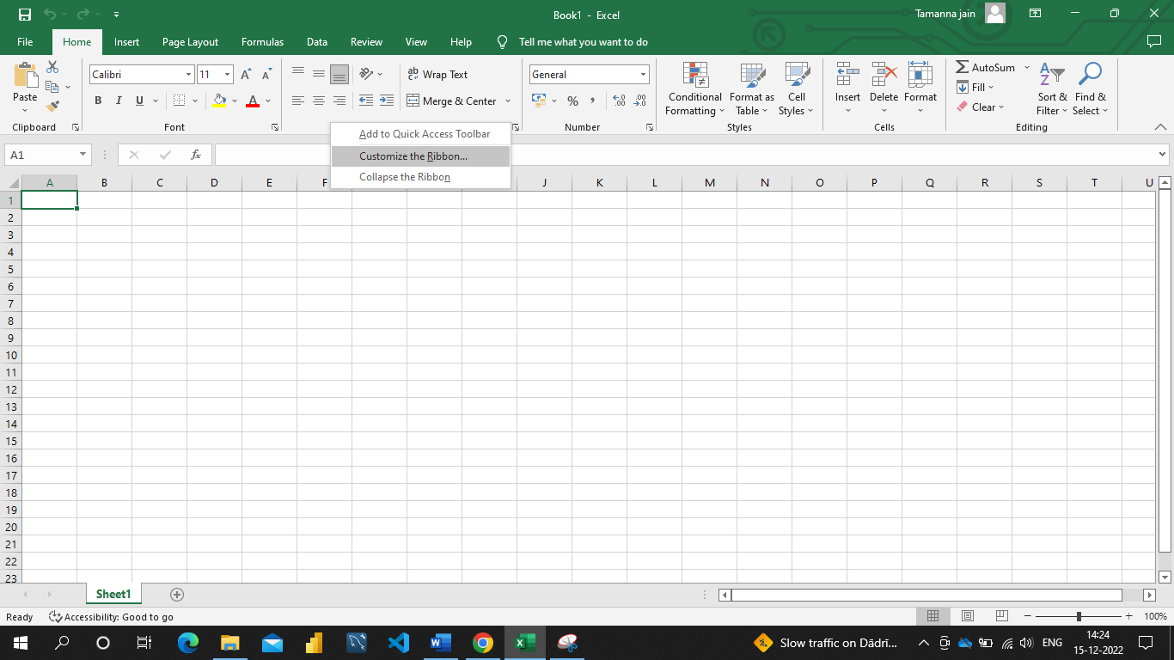Right click on the ribbon anywhere.
* Click on “Customize the Ribbon”, below screen will appear.

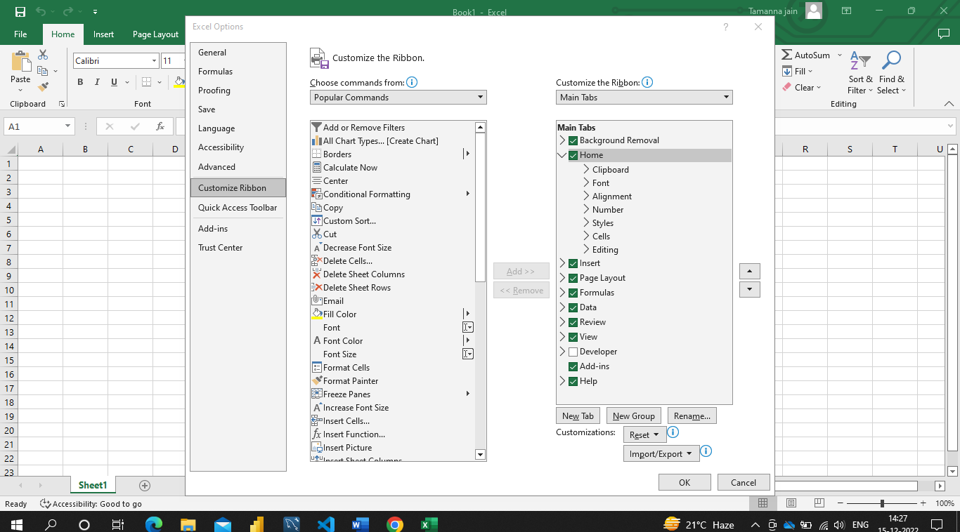

* Click on “New Tab”, It will added the New Tab (Custom) as shown in the below image.

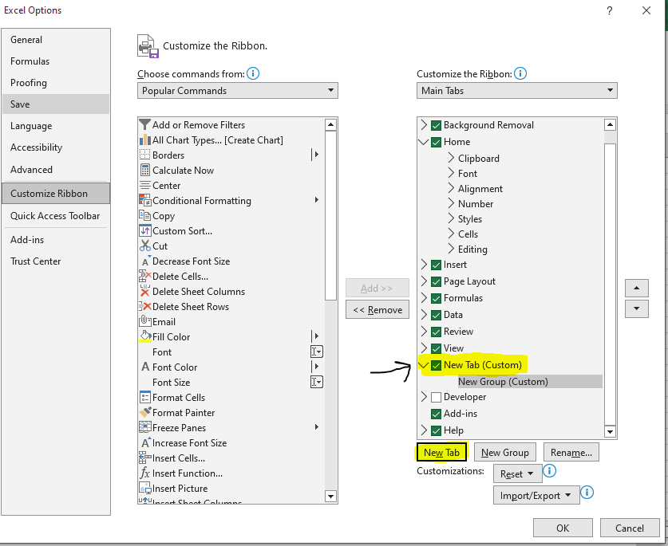

* Add the commands from the left panel for the groups. Click OK.

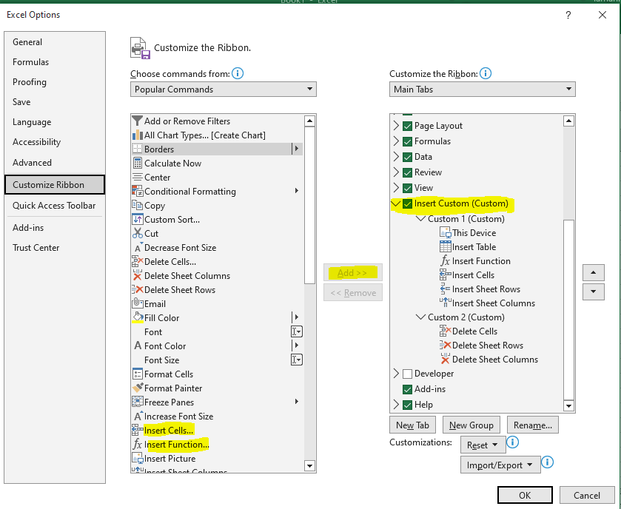

* Now you can see the Insert Custom tab is added into the ribbon.

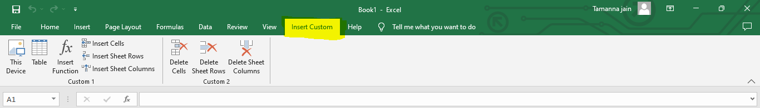

1. Make a list of different shortcut keys that are only connected to formatting with their functions.

Ans.

|  |  |
| --- | --- |
| To do this | Press |
| Display the Font dialog box. | Ctrl+D or Ctrl+Shift+F |
| Increase the font size. | Ctrl+Shift+Right angle bracket (>) |
| Decrease the font size. | Ctrl+Shift+Left angle bracket (<) |
| Increase the font size by 1 point. | Ctrl+Right bracket (]) |
| Decrease the font size by 1 point. | Ctrl+Left bracket ([) |
| Switch the text between upper case, lower case, and title case. | Shift+F3 |
| Change the text to all upper case. | Ctrl+Shift+A |
| Hide the selected text. | Ctrl+Shift+H |
| Apply bold formatting. | Ctrl+B |
| Add a bulleted list. | Ctrl+Shift+L |
| Apply underline formatting. | Ctrl+U |
| Apply underline formatting to the words, but not the spaces. | Ctrl+Shift+W |
| Apply double-underline formatting. | Ctrl+Shift+D |
| Apply italic formatting. | Ctrl+I |
| Apply small caps formatting. | Ctrl+Shift+K |
| Apply subscript formatting. | Ctrl+Equal sign ( = ) |
| Apply superscript formatting. | Ctrl+Shift+Plus sign (+) |
| Remove manual character formatting. | Ctrl+Spacebar |
| Change the selected text to the Symbol font. | Ctrl+Shift+Q |

1. What distinguishes Excel from other analytical tools?

Ans. Excel : **Usage Scenarios**

* + Data processing work under general office requirements.
  + Data management and storage of small and medium-sized companies.
  + Simple statistical analysis for students or teachers (such as analysis of variance, regression analysis, etc.).
  + Combine Word and PowerPoint to create data analysis reports.
  + Assistant tool of data analysts.
  + Production of charts for some business magazines and newspapers (data visualization).

**Advantages**

* It’s easy to get started with Excel.
* The learning resources are very rich.
* You can do a lot of things with Excel: modeling, visualization, reports, dynamic charts, etc.
* It can help you understand the meaning of many operations before further learning other tools (such as Python and R).

**Disadvantages**

* To fully master Excel, you need to learn VBA, so the difficulty is still very high.
* When the amount of data is large, there will be a situation of stuttering.
* The Excel data file itself can hold only 1.08 million rows without the aid of other tools, and it’s not suitable for processing large-scale data sets.
* The built-in statistical analysis is too simple and has little practical value.
* Unlike Python, R, and other open source software, there is a charge for the genuine Excel.

Other Tools : **Usage Scenarios**

* Data crawling.
* Data cleaning.
* Data modeling.
* Construct data analysis algorithms based on the business scenarios and actual problems.
* Data visualization.
* Advanced fields of data mining and analysis, such as machine learning and text mining.

1. Create a table and add a custom header and footer to your table.

Ans.

* Click the worksheet where you want to add or change headers or footers.
* On the Insert tab, in the Text group, click Header & Footer.

Excel displays the worksheet in Page Layout view.

* To add or edit a header or footer, click the left, center, or right header or footer text box at the top or the bottom of the worksheet page (under Header, or above Footer).
* Type the new header or footer text.

Notes:  To start a new line in a header or footer text box, press Enter.

To include a single ampersand (&) in the text of a header or footer, use two ampersands. For example, to include "Subcontractors & Services" in a header, type Subcontractors && Services.

To close headers or footers, click anywhere in the worksheet. To close headers or footers without keeping the changes that you made, press Esc.